**# Cloning a Remote Git Repository from GitHub:**

_ _ _ _ _ _ _ _ _ _ _ _ _

**@ Let's understand 1st what's a remote git repository:**

* Remote repositories are versions of your project that are hosted on the Internet or Network somewhere.

*** Remote Meaning: Conducted or working away from a usual workplace or location [OR] situated far from the main centres of population; distant.

_ _ _ _ _ _ _ _ _ _ _ _ _

**@ Understanding Cloning w.r.t GitHub / Hosting Services / Server:**

* Cloning a remote repository simply means copying all files of a remote repository to the local machine.

* If a project has already been set up in a remote repository, the git clone command is the most common way for users to obtain a development copy.

* Like git init, cloning is generally a one-time operation, after that if anything is updated in the remote repository by anyone then git fetch or git pull command is mostly used to get the updates only.

_ _ _ _ _ _ _ _ _ _ _ _ _ _ _ _ _ _ _ _ _ _ _ _ _ _

--->

**@ Now Let's Clone a Remote Repository from GitHub:**

* Go to any git repository which is present on GitHub, and you want to clone it.

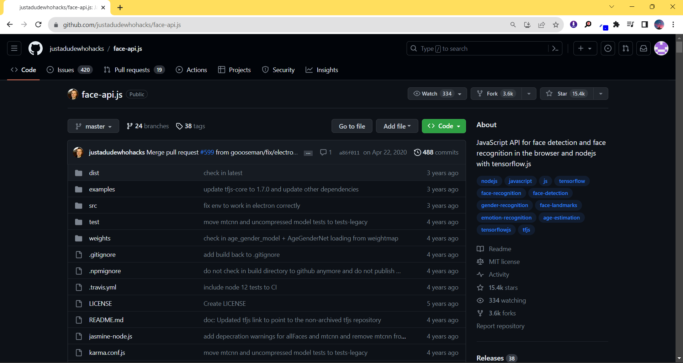

* Now click on "<> Code" Button on that Git Repo's GitHub page.

* Now copy the HTTPS link for Cloning, I have copied this link "https://github.com/justadudewhohacks/face-api.js.git"

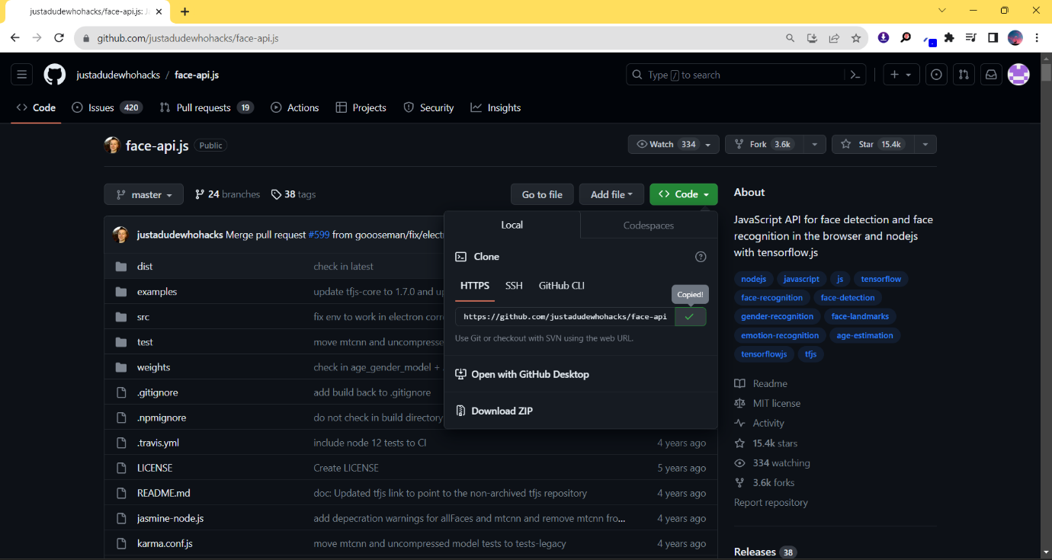

* Now come to the directory where you want to clone this Git Repository, do "Shift + Right click" and open "git bash" in that directory.

* Now run this command.

Command: git clone paste_the_link_here_by_pressing_right_click_and_clicking_on_paste_option [or] press_shift+ins_on_keyboard_to_paste_on_git_bash_console

Ex: git clone https://github.com/justadudewhohacks/face-api.js.git

---> This will make a folder of default name in your current directory as per the git repository and then it will clone the whole git repo from GitHub to your local storage.

* If you want to customize the name of the local folder in which the git repo is getting cloned, then while you're cloning the git repo in the beginning at that time instead of using above command, just give space in the above command in the end after pasting the link and then write the customized name in double quotes, now a local folder will get created of your given customized name and then the whole git repo will get cloned into it.

Command: git clone https://github.com/justadudewhohacks/face-api.js.git "Face API"

_ _ _ _ _ _ _ _ _ _ _ _ _ _ _ _ _ _ _ _ _ _ _ _ _ _

--->

**# References Cited:**

* 5th Video of CodeWithHarry (Complete Git Tutorials For Beginners In Hindi) Playlist : (Cloning a Remote Git Repository from GitHub | Git Tutorials #5):

<https://www.youtube.com/watch?v=R3uS1poPwNM&list=PLu0W_9lII9agwhy658ZPA0MTStKUJTWPi&index=5>

_ _ _ _ _ _ _ _ _ _ _ _ _ _ _ _ _ _ _ _ _ _ _ _ _ _ _